**Everyday Analysis**

* See all the data imported:
* select * from everyday_data;
* **DATA CLEANING:**

Cleaning the Item_Fat_Content field ensures data consistency and accuracy in analysis. The presence of multiple variations of the same category (e.g., LF, low fat vs. Low Fat) can cause issues in reporting, aggregations, and filtering. By standardizing these values, we improve data quality, making it easier to generate insights and maintain uniformity in our datasets.

**update everyday_data**

**set item_fat_content=**

**case when item_fat_content in ('lf','low fat') then 'low fat'**

**when item_fat_content ='reg' then "regular"**

**else item_fat_content**

**end;**

After executing this query check the data has been cleaned or not using below query

**select distinct item_fat_content from everyday_data;**

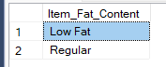

**A. KPI’s**

**1. TOTAL SALES:**

**select cast(sum(total_sales)/1000000 as decimal(10,2)) as total_sales_in_millions from everyday_data ;**

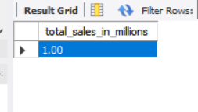

1. **AVERAGE SALES**

**select avg(total_sales) as average_sales from everyday_data;**

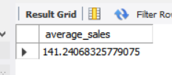

1. **NO OF ITEMS**

**select count(*) as number_of_items from everyday_data ;**

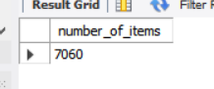

1. **AVG RATING**

**select avg(rating) as avg_rating from everyday_data;**

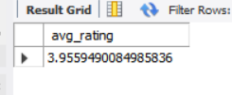

**-- granular requirements**

1. **total sales by fat content,**
2. **total sales by item type,**
3. **fat content by outlet for total sales**
4. **total sales by outlet establishment year**

**>select item_fat_content,sum(total_sales) from everyday_data group by Item_Fat_Content ;**

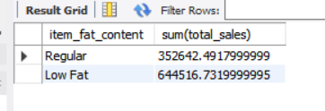

**>select item_type,sum(total_sales) from everyday_data group by Item_type;**

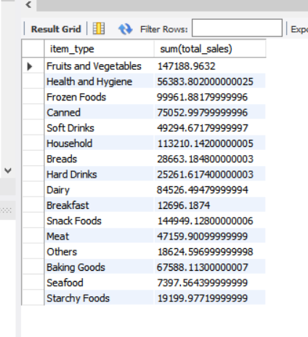

**select Outlet_Type,sum(total_sales),item_fat_content from everyday_data group by Outlet_Type,item_fat_content;**

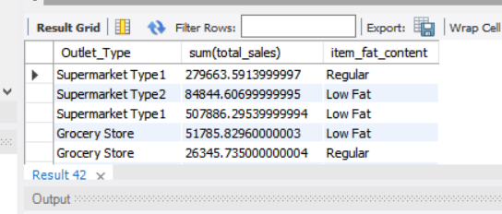

**>select outlet_establishment_year, sum(total_sales) from everyday_data group by outlet_establishment_year;**

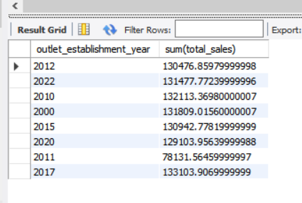

**F. Percentage of Sales by Outlet Size**

select outlet_size, sum(total_sales) as outlet_sales, (sum(total_sales)*100.0)/(select sum(total_sales) from everyday_data) as sales_percentage from everyday_data group by outlet_size;

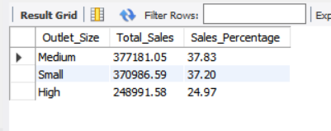

**G. Sales by Outlet Location**

**>select outlet_location_type,sum(total_sales) from everyday_data group by outlet_location_type;**

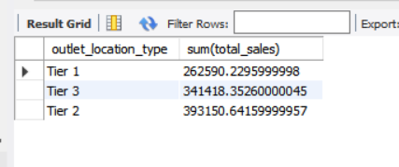

**H. All Metrics by Outlet Type:**

**>select outlet_type,sum(total_sales) as total_sales,avg(total_sales) as avg_sales,count(*) as no_of_items,avg(rating) as avg_rating,avg(item_visibility) as item_visibility from everyday_data**

**group by outlet_type**

**order by total_sales desc;**

